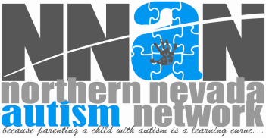

2015 APPLICATION FOR INTERVENTIONIST

Please note: Once submitted your application will be provided to NNAN families in Elko/Spring Creek that are in need of hiring an interventionist. The families will contact you regarding hours and rate of pay.
Submit your application to info@nnan.org

Name:

Phone number:

Alternate phone number:

Email:

Do you have transportation?

Are you at least 16? 18?

Are you able to work during the school day?
Are you able to work in the afternoons?
Are you available to work on the weekends?

Are you CPR certified?
Are certified in first aide?

Why are you interested in working with children with autism?

What training do you have?

